**Election Analysis using Python and VS Code**

With various different ballet styles and ways to accurately and precisely calculate the winner in a timely manner, clients Seth and Tom, reached out to our team to find a solution and potentially a way to calculate election tallies for years forward. With the use of Python and VS code, the original CSV data was able to be analyzed quickly to determine the winner, county turnout, and total votes. This information provided a clear story to better understand voter trends that eventually led to the winner, Diana Degette.

For this congressional election, there were 369,711 votes counted from counties: Jefferson, Denver, and Arapahoe. From the total casted votes, Jefferson had 38,855 votes, Denver had 306,055 votes, and Arapahoe had 24,601 votes. In respect to the total votes (369,711), this contributed to 10.5%, 82.8%, and 6.7% respectively for Jefferson, Denver, and Arapahoe counties (Figure 1). Denver had the highest voter turnout and Arapahoe had the lowest.

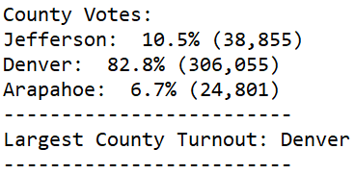

**(Figure 1)**

The winner of the congressional election from data collected from Jefferson, Denver, and Arapahoe awarded Diana Degette as the winner with a winning vote count of 272,892 out of 369,711 total votes (73.8% of votes). Charles Castper Stockham came in 2nd with 85,213 votes (23%), and Raymon Anthony Doane with 11,606 (3.1%) (Figure 2).

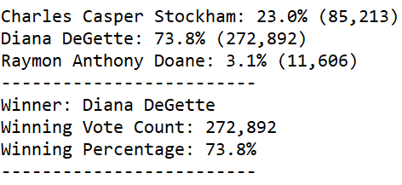

**(Figure 2)**

In summary, congressional candidates must focus on counties with highest voter turnouts as this will make the greatest impact for desired election results. With 82.8% of the total vote counts, Jefferson and Arapahoe did not have the weight to overturn the weight/presence from Denver. For the future, this Python code can be re-used and re-purposed for any election commission current and future with a few modifications. The code has been created to reference a specific csv file with ballot ID, county, and candidate information so in order to run this for different results, the reference file will need to be changed to point to the raw data source to analyze. The other modification is to save a new save outsource file to ensure that existing election summaries will not be overridden. This means that a new output location must be created on the file path to ensure that new elections do not replace data from prior elections (Figure 3).

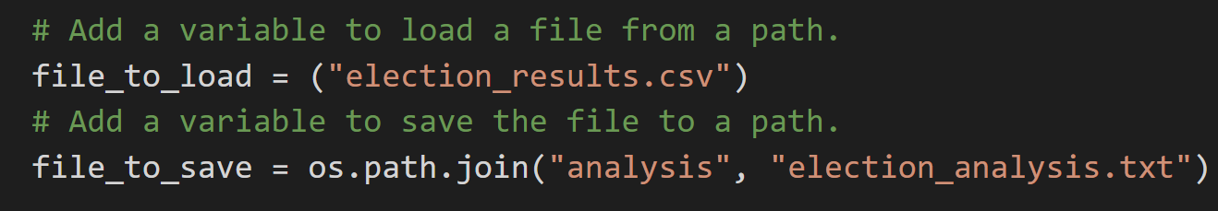

**(Figure 3)**